**WORKFLOW OF MY MARKETPLACE**

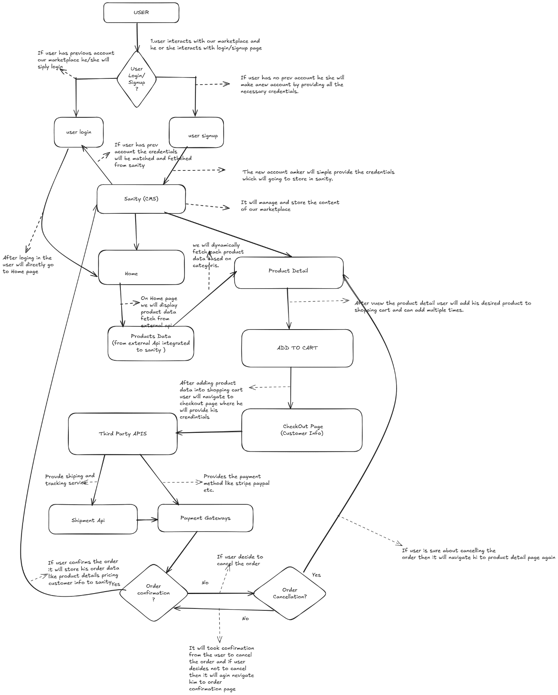

**User Authentication:**

If user has previously made an account so he she simply has to provide credintials and his data will be fetched from sanity.

**Product data:**

We will fetch our required product data from sanity and then for product detail we will handle it dynamically.